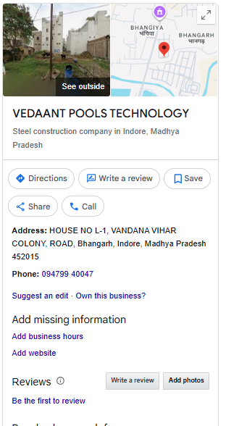
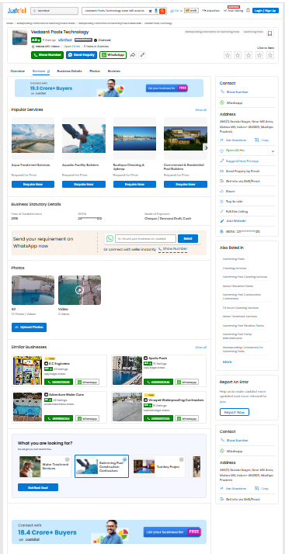
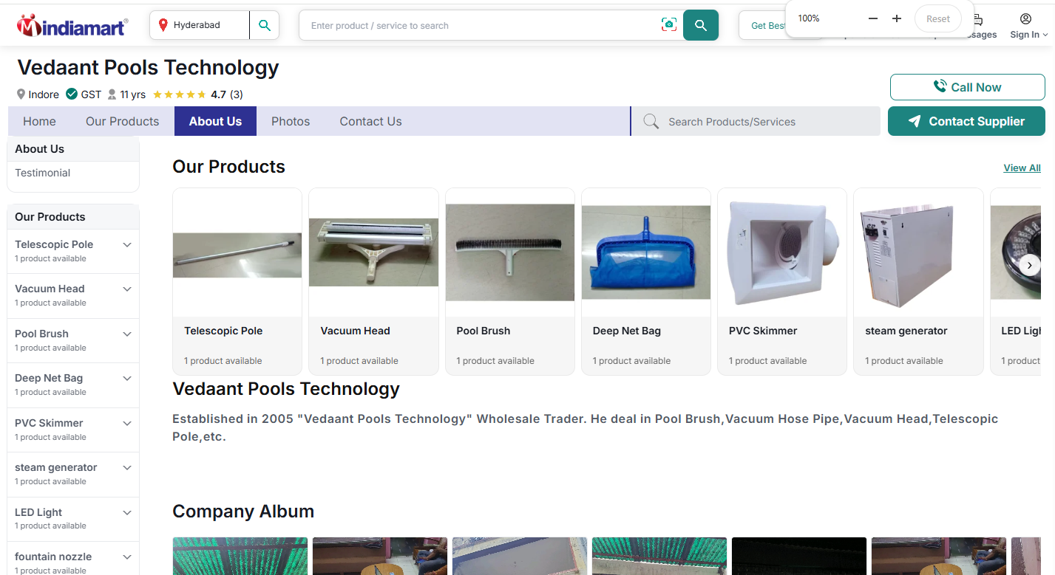
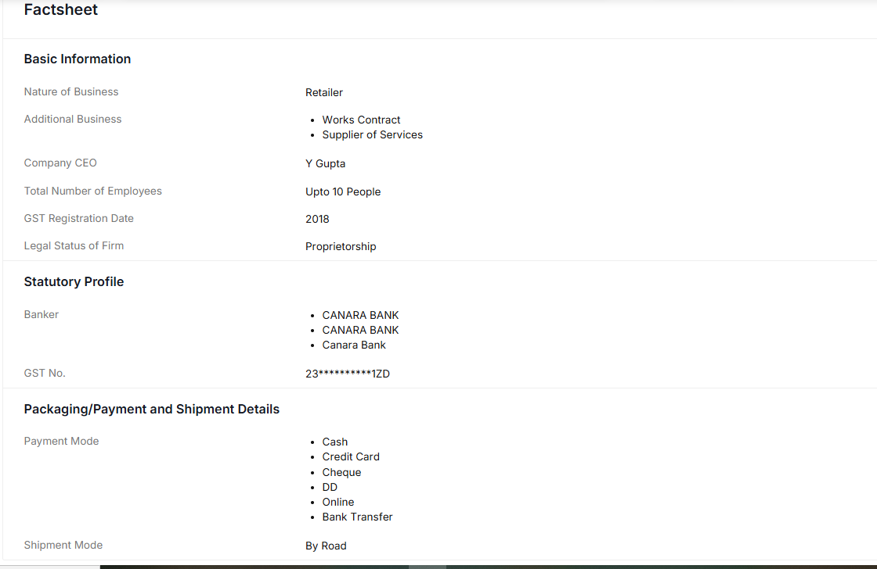

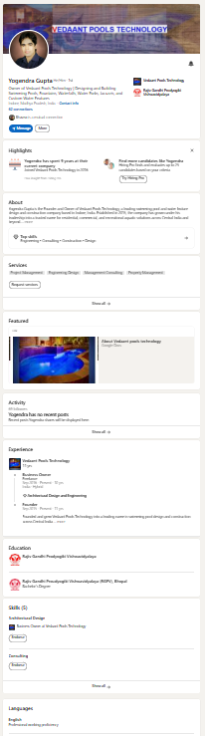
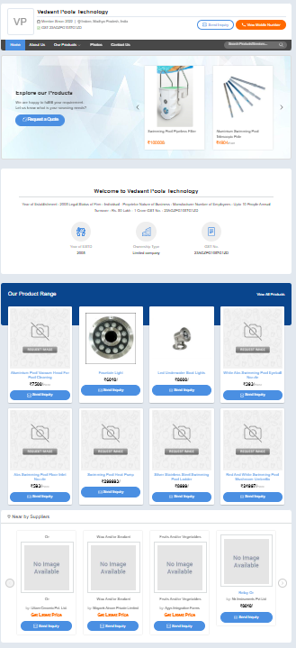
Here is the comprehensive, verified compilation of all corporate, operational, product, and logistical information for Vedaant Pools Technology.

🏢 Corporate & Business Profile

- Company Name: Vedaant Pools Technology
- Year of Establishment: 2018 (Operated by leadership with over a decade of domain expertise)
- Business Type: Sole Proprietorship
- Founder & Owner: Yogendra Gupta (also referenced as Y. Gupta in trade filings)
- Primary Roles: Manufacturer, Retailer, Works Contractor, and Service Provider
- GST Identification Number (GSTIN): 23AGZPG1057G1ZD (Registered in Madhya Pradesh) [1, 2, 3, 4, 5]

📍 Contact & Geographic Data
The firm manages its operations out of two primary coordinates in Indore: [5]

- Registered Head Office: House No L-1, Vandana Vihar Colony Road, Bhangarh, Indore, Madhya Pradesh
- Commercial / Correspondence Address: 450/3, Nanda Nagar, Indore - 452003, Madhya Pradesh, India
- Primary Service Areas: Complete turnkey operations across Indore and neighboring regions of Central India.
- B2B Sourcing Hotline: +91-8043862448 [1, 3, 5, 6]

[Rich media excluded from paste]

🛠️ Core Services & Engineering Domain
Vedaant Pools Technology functions as an end-to-end aquatic infrastructure contractor: [3, 7]

- Swimming Pool Engineering: Turnkey design, structural construction, and complete filtration plant setups.
- Waterproofing Specialization: Major local contractor for structural pool waterproofing to prevent sub-surface leakage.
- Water Features: Conceptual design and execution of waterparks, artificial rock fountains, and outdoor waterfalls.
- Wellness Suites: Complete room design and technical deployment for commercial or home jacuzzis, saunas, and steam baths.
- Maintenance & Sanitation: Professional swimming pool cleaning and water filtration treatment services. [3, 4, 7, 8, 9]

📦 Product Catalog & Price Structure
The business serves as a heavy equipment distributor, retailing pool safety, upkeep, and atmospheric hardware on channels like IndiaMART: [2]
Product Category | Item Description | Standard Unit Price (INR) | Material / Tech Specs
Sanitation & Upkeep | 18-inch Aluminium Vacuum Head | ₹4,500 / Piece | Heavy-duty, pool bottom cleaning
Sanitation & Upkeep | 3-Metre Telescopic Pole | ₹2,500 / Piece | Rigid structural reach handle
Sanitation & Upkeep | Professional Cleaning Brush | ₹2,000 / Piece | Curved pool wall scrub bristle
Sanitation & Upkeep | Deep Leaf Net Skimmer | ₹1,450 / Piece | Reinforced deep mesh net bag
Plumbing & Controls | White ABS Eyeball Nozzle | ₹2,500 / Piece | Single-hole directional return wall jet
Plumbing & Controls | Heavy Duty PVC Pool Skimmer | ₹2,500 / Piece | 220V structural surface skimmer
Atmospheric Lighting | 20W LED Underwater Pool Light | ₹4,500 / Piece | Waterproof illumination array
Atmospheric Lighting | 20W LED Fountain Light | ₹4,500 / Piece | Submersible focal spot lighting
Structural Accents | Stainless Steel Fountain Nozzle | ₹1,200 / Piece | Rust-proof high-pressure spout
Spa & Wellness | 6kW Heavy Steam Bath Generator | ₹35,000 / Piece | Automated residential/commercial spa boiler

💳 Logistics & Transaction Policies

- Accepted Payment Modes: Cash, Credit Card, Cheque, Demand Draft (DD), Online Net Banking, and direct Bank Transfers.
- Shipping & Distribution: Dispatched directly By Road using regional commercial freight.
- B2B Commitments: Trade portals list a standard dispatch policy of free shipping on cataloged equipment arrays, maintaining a strict non-returnable policy on custom-cut or structural hardware lines.
- Public Sentiment: Holds a perfect 5.0-star local execution track record on industry listing portals. [2, 10, 11]

